**Tutorial 7**

**Binary Trees**

**Instructions**

1. All tutorial sheets will be posted on the Google Classroom.

2. Students are advised to submit tutorial sheets solutions in classroom.

Q1. Write a program in C to create binary trees using (i) Array (ii) Link List

Q2. Write a program to find the Height of a binary tree.

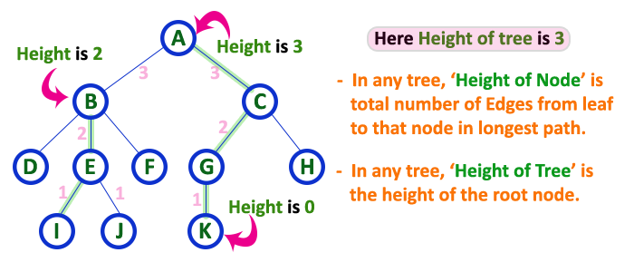

Q3. Write a program to delete a given element from binary tree.

Q4. Write a program to search an element in a given binary tree.

Q5. Write a program to calculate depth of a particular node.

Sample input: Enter the node whose depth needs to be calculated: K

Output: Depth of K is 3

Enter the node whose depth needs to be calculated: Z

Output: Node not found

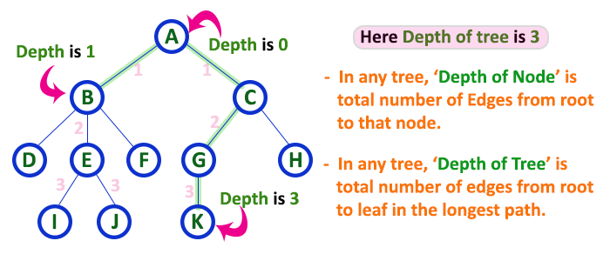

Q6. Construct the binary tree from given Inorder and Preorder traversals:

Inorder sequence: D B E A F C

Preorder sequence: A B D E C F